SEND – What is it?  SEND stands for Special Educational Needs and Disabilities. This acronym is applied to any child who receives additional support above and beyond what the teacher can offer, in order to support their learning and progress.  It is our job to support parents and carers in providing the best possible education for our children. For some of our kids, it means getting them additional SEND support.  Children and young people with SEND all have learning difficulties or disabilities that make it harder for them to learn than most children and young people of the same age. These children and young people may need extra or different help from that given to others.  SEND – What does it look like?  We measure SEND in 3 Waves, as shown below.  Wave 1 – SEND Support which happens within the classroom. This is usually differentiated work by the class teacher. Children who have a medical need, but require no further support with it are also on this wave.  Wave 2 – Children who receive extra interventions within school for their SEND are on this wave. Teaching assistants may do additional work with children to help support their learning.  Wave 3 – Children who are on Wave 3 are children who have external agencies involved with supporting their learning. This could include Speech and Language Therapists, STARS (Specialist Training in Autism and Raising Standards) and SENIT (Special Educational Needs Inclusive Team).  What to do if you think your child has SEND.  If you think your child has SEND, you should talk to your child’s early education setting, school, college or other provider.  They will discuss any concerns you have, tell you what they think and explain to you what will happen next.  There are other sources of information, advice and support you can access such as:  • your local authority’s Information, advice and support service  • your doctor, or other local child health services  • charities and other organisations that offer information, advice and support. You should be able to find information about these from your local authority’s Local Offer.  What types of SEND are there?  “Every child matters.”  Communicating and interacting – for example, where children and young people have speech, language and communication difficulties which make it difficult for them to make sense of language or to understand how to communicate effectively and appropriately with others.  Cognition and learning – for example, where children and young people learn at a slower pace than others their age, have difficulty in understanding parts of the curriculum, have difficulties with organisation and memory skills, or have a specific difficulty affecting one particular part of their learning performance such as in literacy or numeracy. |  | Bramley Park Academy  Fairfield Hill  Leeds  LS13 3DP  0113 2564888  office@bramleyparkacademy.co.uk www.bramleyparkacademy.co.uk
 |  |  |  | 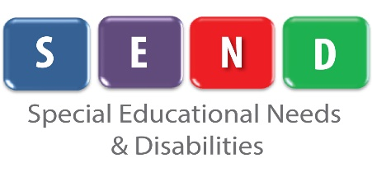

Key Personnel:
Nicola Booth and Sally-Ann Akitt – SENDCOs
Lynn Dove – Learning Manager

0113 2564888

Social, emotional and mental health difficulties – for example, where children and young people have difficulty in managing their relationships with other people, are 8 withdrawn, or if they behave in ways that may hinder their and other children’s learning, or that have an impact on their health and wellbeing.
Sensory and/or physical needs – for example, children and young people with visual and/or hearing impairments, or a physical need that means they must have additional ongoing support and equipment. Some children and young people may have SEN that covers more than one of these areas.

