Homework Policy

Bramley Park Academy is committed to safeguarding and promoting the well-being of all children and expects our staff and volunteers to share this commitment.

Policy reviewed by: M Ward
Date: Sept 2020
Review Date: Sept 2022

Bramley Park Academy Homework Policy

Why do we have homework?
- Homework supports children in maximising their progress in their academic development within school;
- Individual homework encourages children to develop confidence and self-discipline to study on their own and prepares them as independent learners;
- It promotes opportunities to build on life skills and provides wider experiences to prepare our children as future learners;
- Additional learning further develops skills and understanding, particularly in English and Maths, revising consolidating and reinforcing through additional practice at home;
- Homework promotes co-operation between home and school and strengthen the partnership to help all children within our community succeed.
What homework will be given?
At Bramley Park Academy, homework will take the form of a #dosomethingdifferent grid and basic skills.
#dosomethingdifferent
Children will be given a #dosomethingdifferent grid each term with age appropriate activities for them to complete. The grid includes 16 activities, but to earn a badge for their hard work, children only need to complete 10 activities. This allows children, and families, to choose what homework to complete based on their own interests. The activities will encourage children to use a range of skills linked to the curriculum areas, in addition to providing fun experiences for the whole family to complete if they wish.
The grid will look a little something like this:
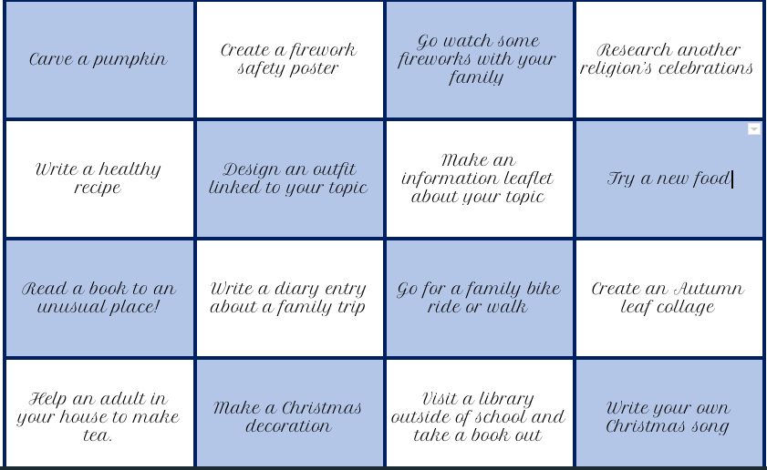
Basic Skills
You will also need to complete the tasks below every week:
- Home reading - We love our pupils to read as often as possible, 10minutes every night, as soon as a pupil has finished a book, they can hand it to their teacher, and they will be given a new one the very next day! When a child returns their home reading book, they will receive a raffle ticket, which will enter them into a half termly draw to win a prize!
- Times Table rockstars - Log in every week to practice times tables.
- Spelling/phonic activity - Complete this once a week.

How will you access and record homework?
A child’s homework activities will be posted into their online classroom each week.
A child’s reading book will be sent home with them, with a reading record to enable parents and teachers to communicate regarding a child’s reading progress.
We would love to see our pupils upload their pictures and examples of home learning onto their google classroom each week.
If parents cannot access the google classroom at home, please contact the school office/child’s teacher, following social distancing guidelines, to receive paper copies and a homework log.
The high standards that are seen in school should be echoed in homework.
How will homework be celebrated?
Children will be awarded a badge for completing 10 challenges in a term in our weekly celebration.
Autumn Term - Orange
Spring Term - Green
Summer Term - Yellow
Staff will monitor the progress of basic skills online, and by recording in home reading records.
Celebrations of home learning will also be made in end of year reports and parents’ evenings.

