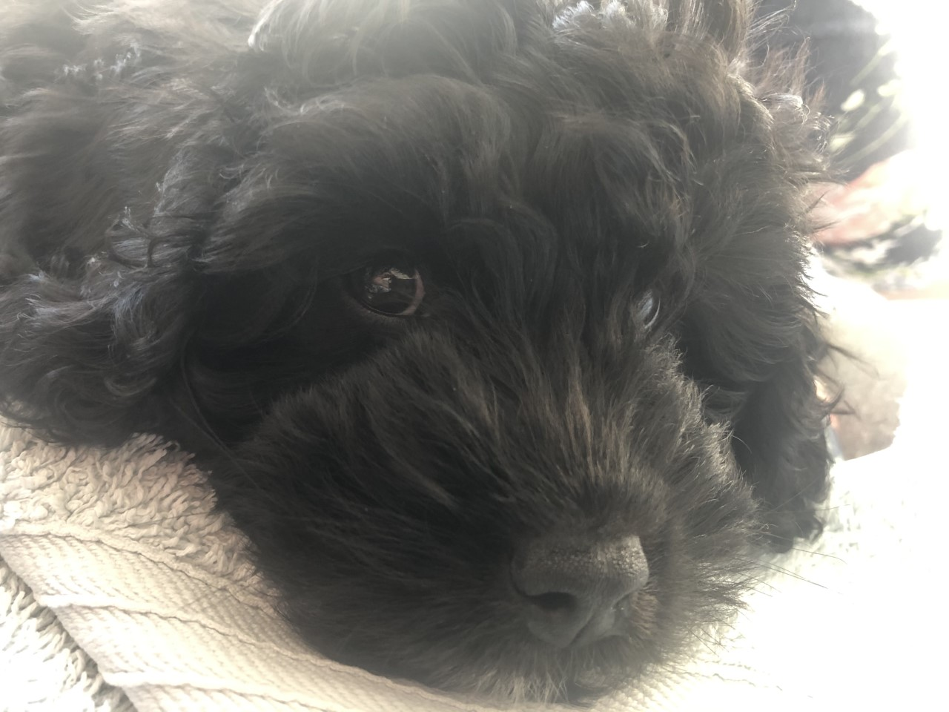
4/5/2020
To all of my wonderful new friends at BPA,

I am Hamish and I will be your new therapy dog at school. I am a Cavapoo, which is a mixed breed of Cavalier King Charles Spaniel and Poodle . We are known for being outgoing, playful, and curious. Us cavapoo pups inherit some of the best traits from both of our parents. This is why I will be an excellent friend for you all at BPA.
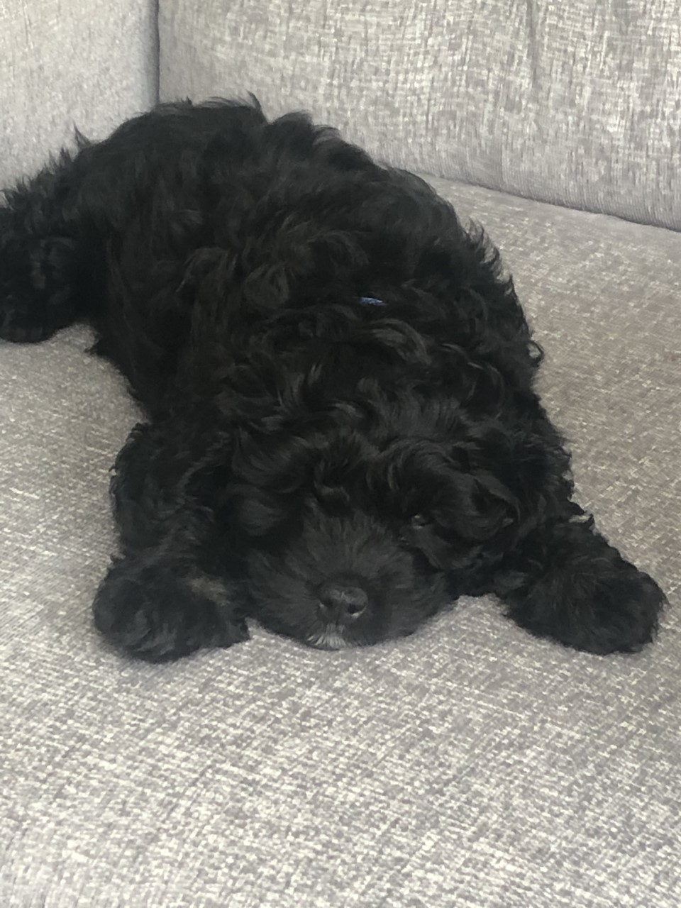
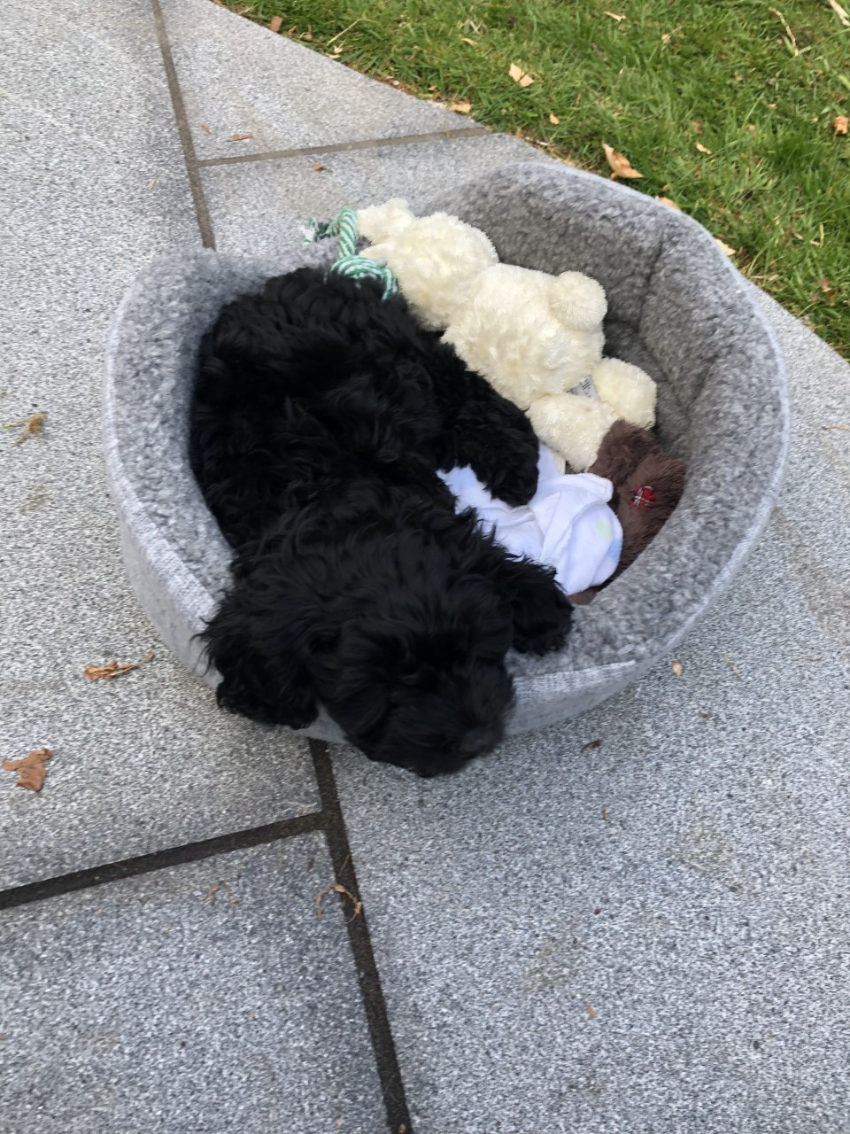
I was ten weeks old on Thursday 20th May, I am a little late with my vaccinations due to the other germs at the moment, but I am ready for dog walks on Friday 8th May. I can't wait to meet you all for exciting walks around the school grounds.
I have grown lots since I arrived at Miss Green’s house - Dylan is helping to take care of me by feeding me yummy biscuits three times a day. As I am only a puppy, I need these to be softened to help me eat them. On a night I sleep in a puppy cage, which helps me to know when to go to the toilet. I am doing a great job with this and am nearly doing all of my toilet trips in the garden.
Last week I went to school for the first time, I really loved jumping in the dandelions! This made me very tired though, so I needed a nap in Mrs Hrintchuk’s classroom.

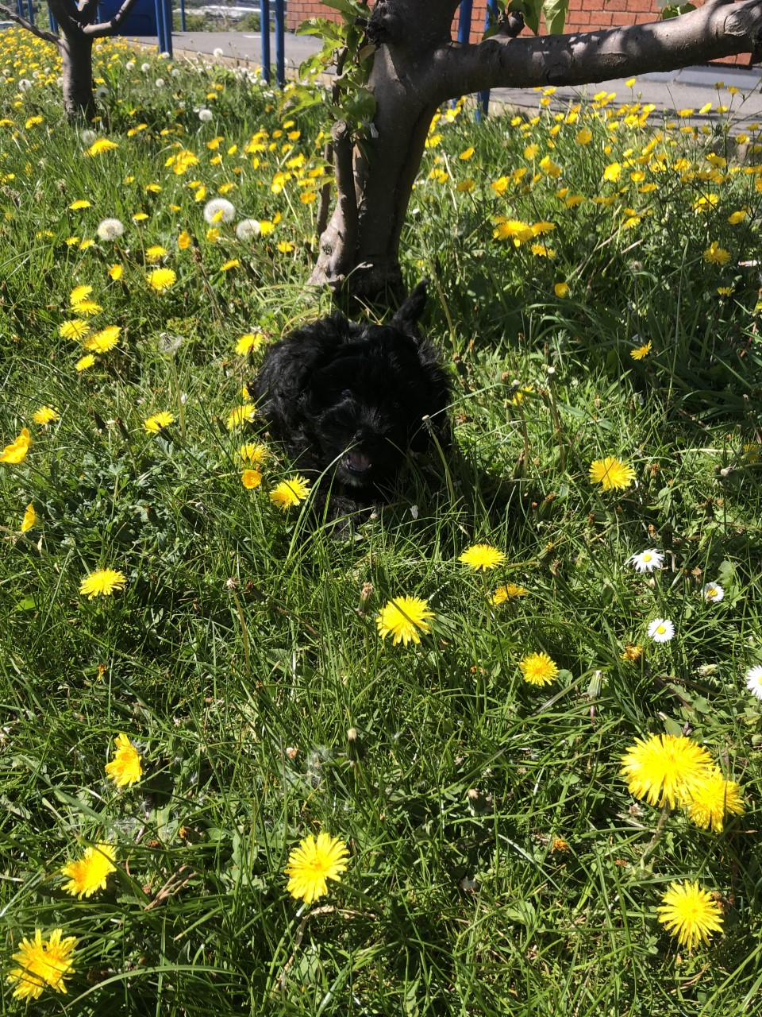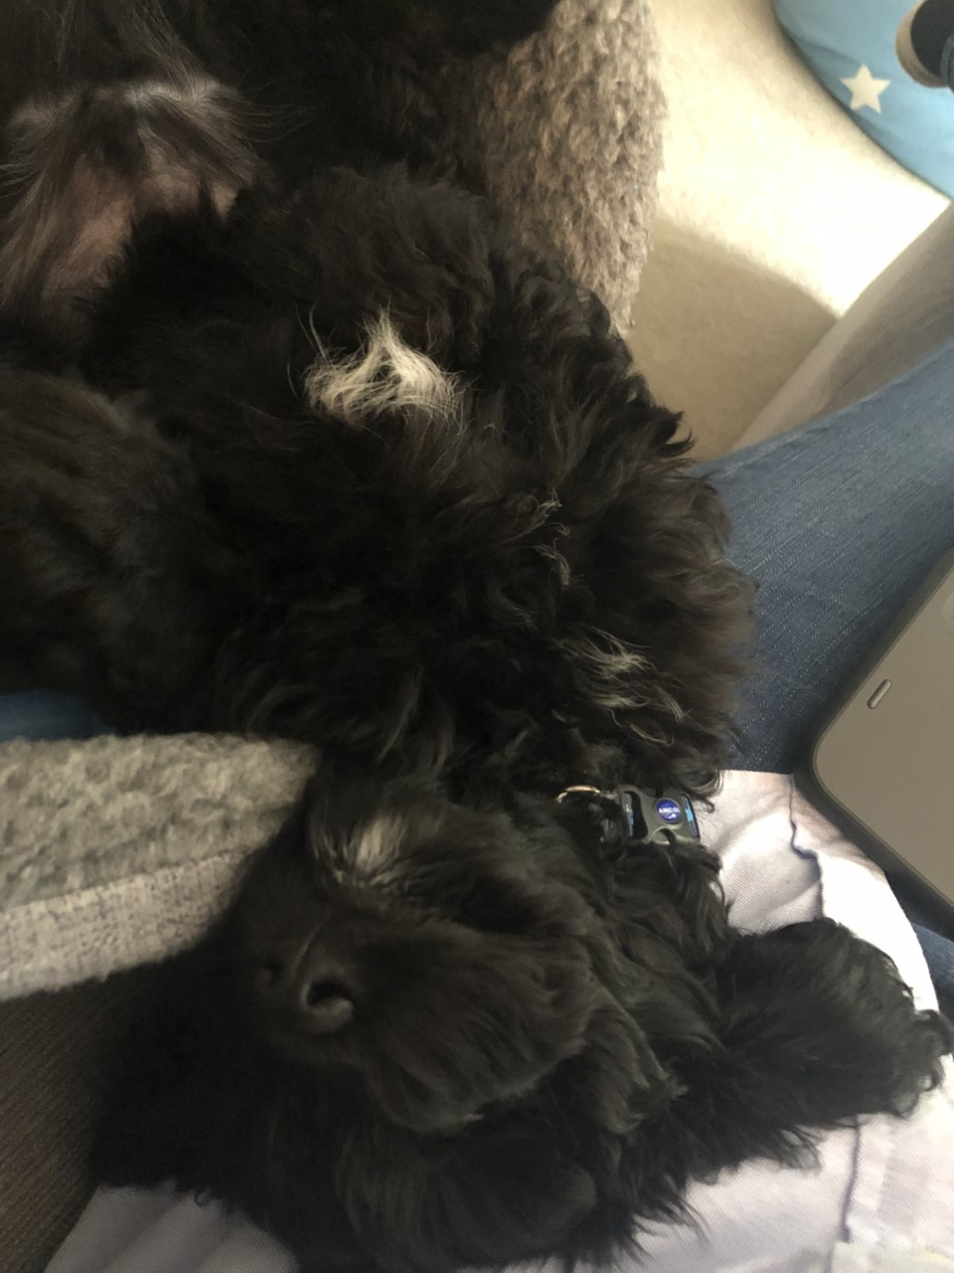

I have also started my training to help everyone read, I know we are going to have lots of fun…I am great company and give the best cuddles!
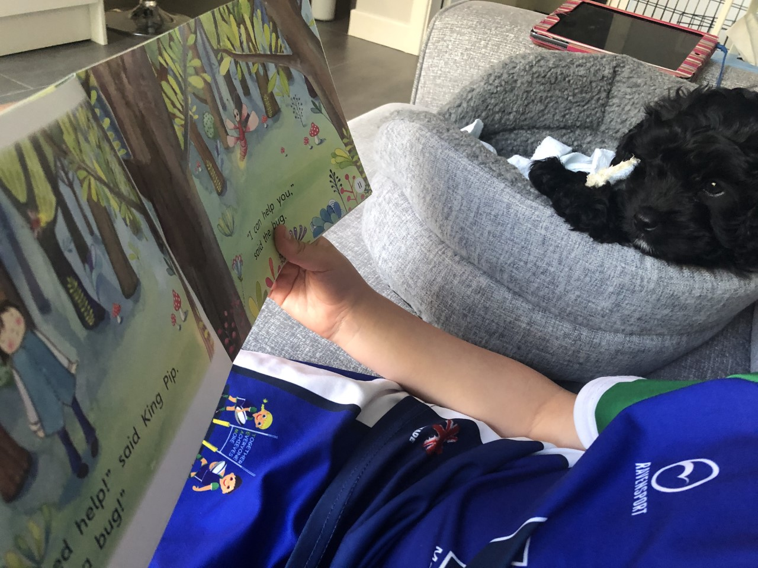

Today I have had a bath and blow dry, so I am all clean and ready for school tomorrow - I can’t wait to see Mr Wingfield and Miss Brown. Miss Marnick is one of my new best friends too :)
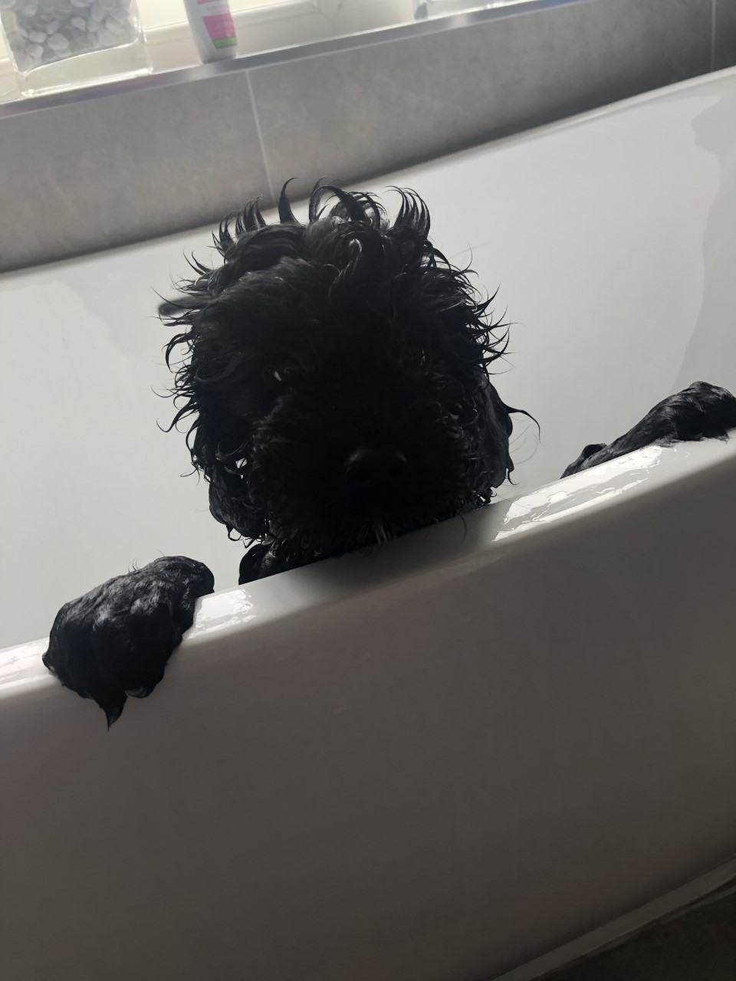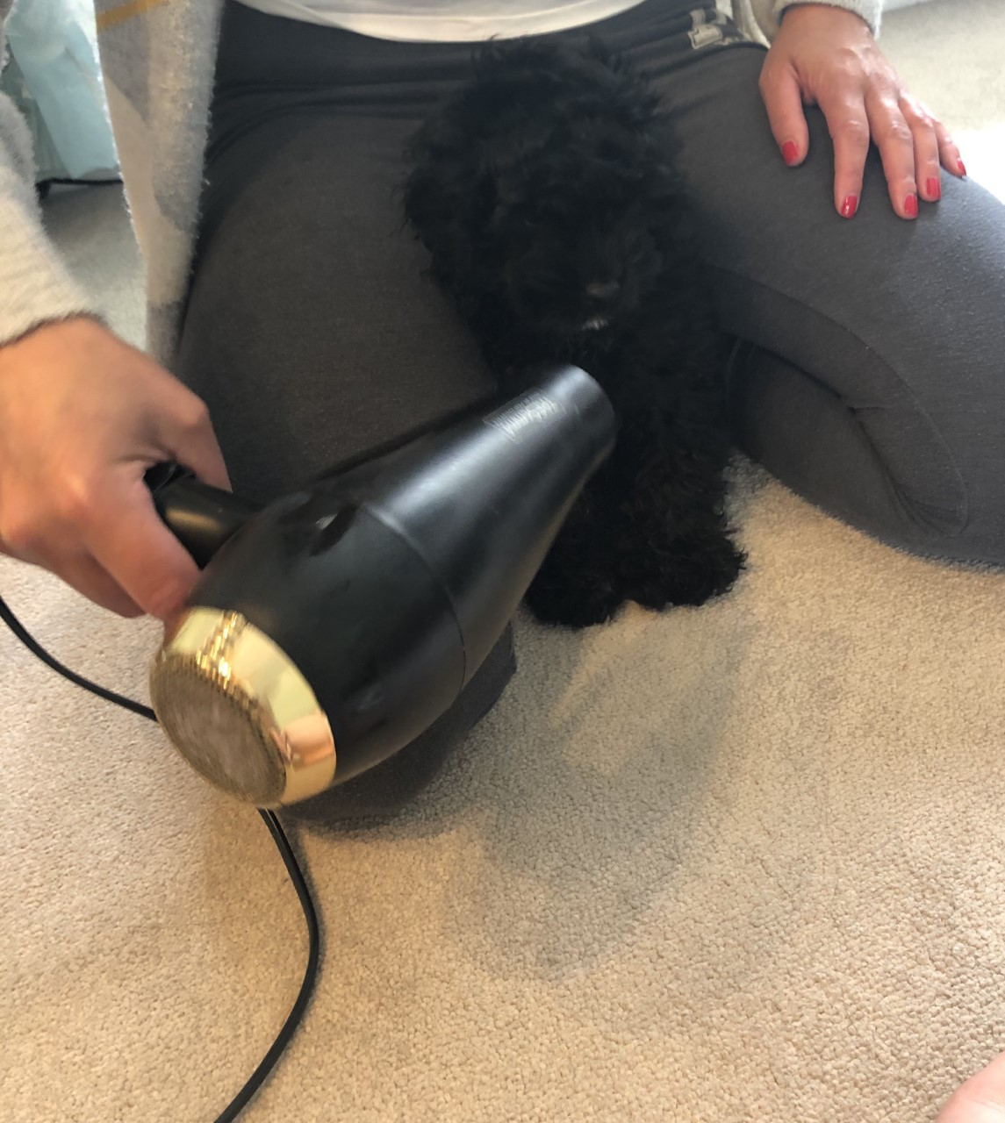
Maybe you can do some research about how to look after me when we hopefully get back to school sometime soon. Email your ideas to your class teacher, who will send onto Miss Green. Keep looking at our twitter page @bramley_park for lots of updates.
I can’t wait to meet you all very, very soon.

Lots of love

Hamish

