Tuesday 18th December 2018

Dear Parent/Carer
Bramley Park Academy Wraparound Care

As you are aware the school has recently consulted with parents/carers with regard to providing after school child care provision during term time only, the result of which was an overwhelming demand for this to be provided.

It is the school’s intention that the after-school programme will be available from Monday 14th January 2019. The programme will be staffed by the current staff whom the children are familiar with and know.

The details and prices are as follows:

After-School Child Care
- Monday – Thursday 3:05pm to 5:30pm - £5.00 per child per session.
- Friday 3:05pm to 5:00pm - £5.00 per child per session.

All children will be provided with a snack (served after 4:30pm). The children will be able to choose to take part in a range of activities.

There is a 25% discount for each additional sibling for any of the above After-School Child Care sessions.

To book any of the sessions or to answer any questions please phone the school office on 0113 2564888. Payment for the wraparound care will be via Parentpay only, please see the school office if you require a Parentpay log-in.

Yours sincerely
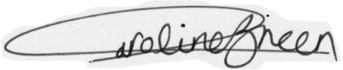
C Green
Executive Principal

